**A Skill and Resources Audit for the Motion Tracking Systems Integration Project**

**1. Project Overview**

Creating software to record and synchronize data from different motion capture devices used in social interaction research is the goal of this project. In order to ensure that devices like Leap Motion sensors, HTC 3.0 trackers, and SlimeVR trackers utilize the same timestamp, the software must be able to synchronize data from these devices. The application should also be easy to use, flexible in terms of customization (e.g., sample rate, start-stop time, data source selection, output format), and capable of fusing motion capture data with audio and video.

**2. Team Skills and Tools**

**· Frontend Development:**

* Ali and Niketh are responsible for designing and implementing the user interface.
* Proficiency in HTML, CSS, JavaScript, and frameworks like React or Angular. Ali and Niketh have the necessary experience to handle this aspect.

**· Backend Development:**

* The backend development is under the supervision of Pengyu, Long, and Zane. And Zane has good research on the hardware.
* Strong command of synchronization, storage, and data processing in Python and C++. They also need to be knowledgeable with SQL and NoSQL database management systems.

**· Testing:**

* Niketh has testing experience, which is important to guarantee the dependability of the programme.
* Knowledge in unit testing, integration testing, and using frameworks.

**3. Required Skills Inventory**

**Technical Skills:**

* **Frontend Development**: Creating a user-friendly interface that is simple, intuitive, and transparent, ensuring ease of use for researchers.
* **Backend Development:** Implementing data synchronization across multiple devices with precision and handling real-time data processing.
* **Data Synchronization:** Expertise in timestamp management and the ability to integrate data from different tracking devices.
* **Video and Audio Integration:** Capability to sync video and audio data with motion-capture data for comprehensive analysis.
* **Testing and Quality Assurance:** Rigorous testing to ensure software reliability and performance.

**Design and Analytical Skills**:

* **User Experience Design**: Design an intuitive interface that meets the researchers' needs.
* **Data Analysis**: Ability to analyze and visualize motion capture data effectively.

**Project Management Skills**:

* **Agile Development:** Proficiency in Agile methodologies to manage project progress and adapt to changes.
* **Version Control:** Using Git for source code management and collaboration.

**4. Available and Required Resources**

**Available Hardware**:

* **SlimeVR Trackers**:
* 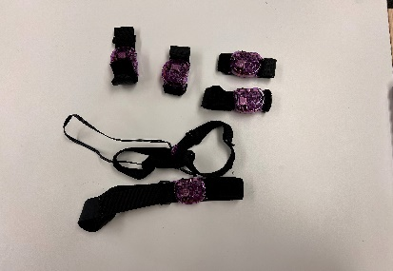 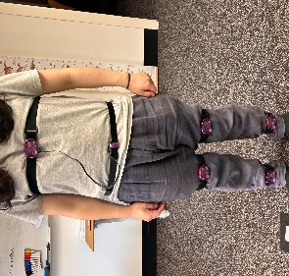

**Pros**: Open source, affordable, can create .bvh files for analysis, has a 12-hour battery life, and offers community support via Discord.

**Cons**: May require custom development for live data capture.

* **HTC 3.0 Trackers**:
* 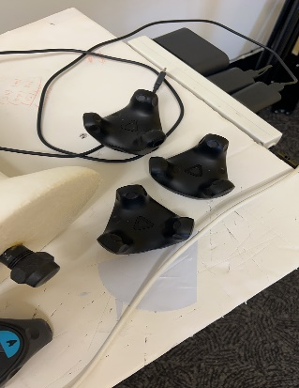 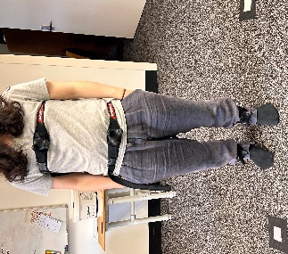

**Pros**: Reliable technology, well-established.

**Cons**: Limited scope for innovation due to existing proprietary development.

* **Leap Motion Sensor**:

**Pros**: Effective for hand tracking, widely used and supported.

**Cons**: Tracking accuracy is not perfect, may require additional techniques to improve precision.

* **Vive Pro 2：**
* 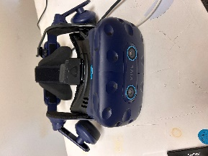

**Pros：**High resolution provides exceptionally clear visuals. Compatible with existing Vive accessories and SteamVR, allowing for easy integration into current setups.

**Cons:** More expensive than comparable VR headsets, which limits its usability for those on a tight budget.

**Required Tools and Software**:

* **IDE**: For Python, C++, and front-end programming, use Visual Studio Code as your main integrated development environment. Several programming languages are supported by this adaptable editor, which may also be tailored with extensions to suit different development requirements.
* **Collaboration Tools**: GitHub for version control and MS Teams for team communication.
* **APIs and SDKs**: Access to the necessary SDKs for SlimeVR, HTC 3.0, and Leap Motion for hardware integration.

**5. Additional Considerations**

**Project Requirements**:

* **Synchronization**: Real-time synchronization of data from multiple devices is critical.
* **User Interface**: Must be simple, transparent, and easy to navigate.
* **Exporting Data**: The software should allow exporting data in CSV format, possibly including images of data graphs.
* **Operating System**: The software will primarily be used on Windows.

**Potential Challenges:**

* **Proprietary Technologies:** This may be difficult to manage and integrate many proprietary systems, particularly when trying to synchronize them with an identical timestamp**.**
* **Customization:** To accommodate certain research requirements, such choosing data sources or establishing sample rates, the programme must be extremely configurable.

**6. Learning and Acquisition Plan**

The team will give priority to improving knowledge of data synchronizing technologies in order to create user-friendly and responsive interfaces, as well as optimizing the back end to guarantee reliable data processing and storage. For the front-end and back-end development and data synchronization board, we can go to YouTube above. Here, there is a need for free tutorial resources. I especially recommend Mosh's teaching channel because he offers a detailed front-end and back-end development of the real-world tutorials. The source of learning and access to resources is particularly important. Two examples of Chinese software are BILIBILI and CSDN. Among other things, CSDN offers a wealth of front and backend analysis as well as several in-depth coding courses. The former is a streaming media platform with a vast community of video creators who have posted educational videos on a whim. In order to assist teams in learning version control best practices, we may also visit GitHub and other open-source websites.

**7. Timeline and Prioritization**

Early in the project, the hardware direction should be determined since various hardware has varying operating conditions, which is essential for developing the project's fundamental infrastructure and guaranteeing that all systems function flawlessly from the outset. We should guarantee back-end development and hardware integration in the midst of the project. To guarantee that the motion capture apparatus was functioning properly at every stage and guaranteeing the precision and effectiveness of data collection and processing, several arduous iterations were necessary. To guarantee that the project is responsive and intuitive, the demands of the client should also be continuously considered.

**8. Evaluation and Continuous Improvement**

The team will have weekly project updates and client meetings with an emphasis on skill development, resource allocation, task progress, etc. to guarantee the project's success. By doing this, the team can deal with possible problems and ensure that nobody strays from the plan. A report is provided after every meeting to guarantee openness and effective team communication. In the event that an issue arises, the project manager may receive prompt feedback via the MS Teams chat window, allowing for ongoing project improvement.